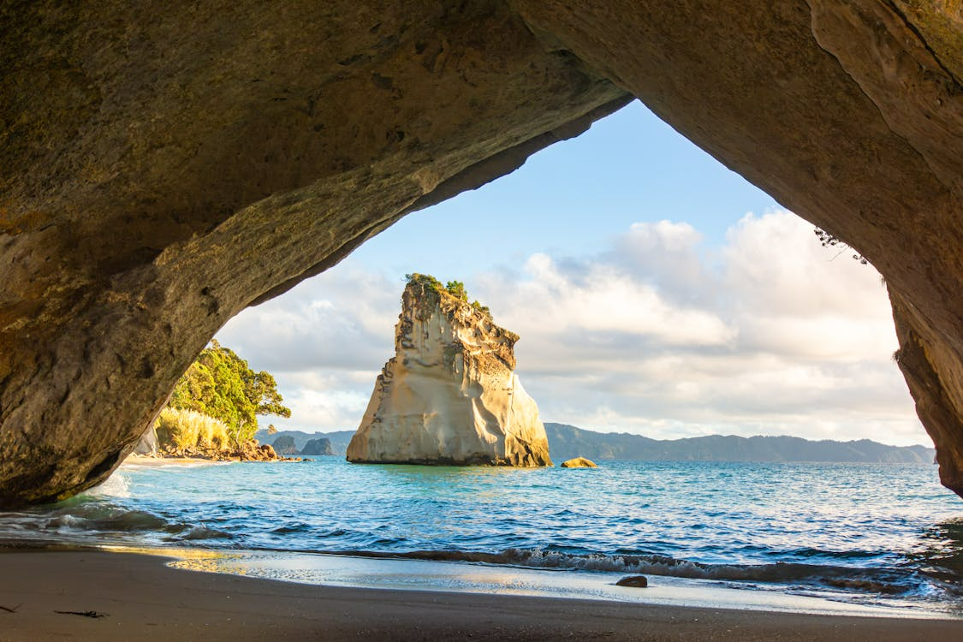

**Coastal Gems of the Coromandel**

**11th – 18th February 2026**

Join us on a scenic and relaxing journey through the stunning Coromandel Peninsula. This thoughtfully paced tour is perfect for travellers seeking natural beauty, local charm, comfortable accommodation, and quality time with fellow travellers. From coastal towns and charming cafés to heritage railways and iconic beaches, each day offers something new .

**DAY 1 – Wednesday 11th Feb. (MT, L, D)**

**Home - Thames**

Your adventure begins as we depart Taranaki and make our way north along the picturesque coast. Our first stop is Mokau, where you’ll be welcomed with freshly baked morning tea and time to connect with fellow travelers.

We continue, through the rolling green hills of the King Country, arriving in the quaint township of Pirongia for a relaxed picnic-style lunch.

By afternoon, we reach the historic town of Thames, nestled at the base of the Coromandel ranges. After checking into our comfortable seaside motel, enjoy a short rest before we head to a highly rated local restaurant for a delicious group dinner.

Accommodation: **Coastal Motor Lodge (078686843)**

**DAY 2 – Thursday 12th Feb. (BF, L, D)**

**Thames – Coromandel Town**

Start the day with a leisurely breakfast overlooking the coast, followed by a visit to the **Thames Goldmine Experience**. Here, a knowledgeable guide takes us through the rich history of gold mining in the region. We then wind our way up the western coast to the tranquil **Rapaura Water Gardens**, with time to stroll at your own pace and enjoy lunch onsite surrounded by nature.

This afternoon brings a touch of fun at **The Waterworks,** an eco-friendly attraction filled with quirky water-powered inventions and nostalgia. By late afternoon, we settle into Coromandel Town for the next two nights. Unwind before another lovely group dinner at a favorite local eatery.

Accommodation: **Anchor Lodge Motel (0** **7866 7992)**

**DAY 3 – Friday 13th Feb. (BF, L, D)**

**Coromandel Town**

Enjoy a relaxed morning start, then we head to the iconic **Driving Creek Railway** — a unique narrow-gauge railway journey climbing through regenerating native bush to stunning hilltop views.

Afterwards, we enjoy a scenic drive north to the quiet village of Colville where we will be treated to some freshly made lunch. We then return to Coromandel Town for some personal downtime or a stroll through the shops and art galleries.

This evening, we gather once more for a memorable dinner at a top-rated local restaurant.

Accommodation: **Anchor Lodge Motel (0** **7866 7992)**

**DAY 4 – Saturday 14th Feb. (B, L, D)**

**Coromandel Town - Whitianga**

Today we travel across the peninsula to the charming seaside town of Whitianga. On our way we call in to Matarangi with a chance to stroll the beautiful white sandy beach.

After visiting the **Mercury Bay Museum**, we’ll enjoy a café lunch before embarking on a scenic **Waterway Cruise**. This 1.5-hour tour explores the Whitianga River and canals, featuring luxury homes, marine wildlife, and rich local history.

The afternoon is yours to relax on the waterfront or browse the local boutiques. Dinner tonight is at a well-loved Whitianga restaurant.

Accommodation:**Mana-Nui Motel (07 8665599)**

**DAY 5 - Sunday 15th Feb. (B, L, D)**

**Whitianga**

A wonderful morning awaits aboard the **Glass Bottom Boat Tour** — a relaxed way to see marine life and the Cathedral Cove coastline without getting wet.

Later, we visit **Whiti Farm Park**, home to friendly farm animals, birds, and quirky exhibits. Enjoy a picnic lunch surrounded by nature.

Our afternoon includes stops at Hot Water Beach, Hahei, and Cooks Beach — iconic Coromandel locations, all accessible and photo-worthy.

After some afternoon rest back at the motel, we head out for another delicious group dinner.

Accommodation: **Mana-Nui Motel (07 8665599)**

**DAY 6 – Monday 16th Feb. (B, L, D)**

**Whitianga - Waihi**

Today we head south, stopping first at the resort town of Pauanui, with views across the harbour to Mt Paku. We continue to Whangamatā for a relaxed beachside lunch.

In the afternoon, we explore **Waihi’s Gold Story**, an engaging multimedia experience that brings the town’s mining history to life. We then experience the **Waihi Gold Mine Tour** with the permission of OceanaGold we go inside the security fence of the working OceanaGold Waihi Mine site to discuss current activities, the colourful past and information about how modern gold and silver mining is achieved.

We settle into our accommodation for the night before heading out for dinner together at a local restaurant.

Accommodation: **Goldmine Motel (07 863 7111)**

**DAY 7 – Tuesday 17th Feb. (B, L, D)**

**Waihi - Rotorua**

We journey through the Bay of Plenty with two special highlights. The first stop is a hands-on farm experience at **The Good Farm** which featured on Country Calendar. Enjoy time with animals and learning about regenerative practices.

We then head for a guided tour and tasting at **Kiwifruit Country**, where you’ll learn about gold kiwifruit cultivation and enjoy fresh morning tea of kiwifruit, scones with kiwi jam, and a cuppa.

We stop for lunch en route, then arrive in Rotorua for a **Redwoods Treewalk**, a peaceful walk through towering Californian redwoods on a gently elevated walkway.

After a short city tour, we check in to our hotel and enjoy a farewell dinner together.

Accommodation: **Rydges Rotorua (07 3481 189)**

**DAY 8 – Wednesday 8th Feb. (B, L)**

**Rotorua - Home**

Relaxed start to the day and after a hearty breakfast we start making our way home to Taranaki stopping at Piopio for a delicious lunch.

**Total Cost Coromandel Tour 2026:**

**Tour payments per person**

* Twin/Double share: **$ 3530 pp** ex New Plymouth/Hawera/Wanganui
* Single Supplement: **$ 4450 pp**
* Deposit due at time of booking **$800 pp**

**Please note your seat is not secure until deposit has been paid!!**

Balance of tour payment due 60 days prior to departure – 13th December 2025

**Tour Cost Covers:**

* All activities/attractions stated in **bold**.
* All coach travel as stated in the itinerary.
* 2 course or buffet dinners every night.
* Breakfast every morning (continental)
* Lunch on days indicated
* Morning & afternoon teas as stated in itinerary.
* Twin share accommodation (single supplement available if you do not have a travel partner)
* Experienced Tour Leader.
* Quality tour coach.
* Tour photos.

**Terms & Conditions….**

(Applicable for New Zealand Tours 1 March 2025 – 30 June 2026)

**Acceptance Of Terms & Conditions**

If you have booked a tour with us and pay your deposit, you are deemed to have accepted these terms. We may ask you to sign a copy of these terms when you join a tour to provide a record that you have accepted these terms.

**Itineraries**

The Itinerary for your tour package was correct at the time of date and printing, however it is subject to change without notice. Your itinerary could change due to road or weather conditions, changes imposed by other tour operators or a range of other factors beyond our control. You agree that we have no liability to you for changes to your itinerary.

**Price Amendments**

Prices were correct at the time and date of printing; however, Weir Bros Ltd reserves the right to amend the price subject to any changes in price imposed by other tour operators and carriers included in the itinerary or increases in government or other levies.

**Health & Fitness**

All passengers are required to acknowledge they are in reasonable health and are considered fit to travel and are not travelling contrary to any medical advice. Passengers should be able to walk moderate distances to be able to participate in activities and sightseeing opportunities. By acknowledging their health and fitness to participate passengers are indemnifying us from all actions, claims and demands arising out of any lack of health and fitness. We reserve the right to remove a passenger from a tour if their health or fitness interferes with any other passenger’s experiences or the day-to-day running of the tour.

**Travellers Who Require Assistance**

We kindly request that, as part of joining our Packaged Tour, you share with us at the time of booking any disabilities or conditions that may require special attention. This includes, but is not limited to, physical disabilities, difficulties with mobility, impairments in hearing or eyesight, or neurological conditions. Should your health circumstances change after booking and before your travel date, we respectfully ask that you inform us of any new needs for special assistance. Please rest assured that we will make every effort to accommodate such requirements. However, we must highlight that there may be situations where we are unable to do so, and we cannot be held responsible in cases where services are denied by third-party providers, including airlines, accommodations, or tour operators. Where a minimum level of mobility is required to participate in a tour, we reserve the right to deny a passengers travel request, for both their safety and the safety of staff and other passengers.

**Health & Safety Information including COVID-19**

At Weir Bros our first priority is your safety and enjoyment while you are travelling with us.

While we have always maintained a high standard of cleaning on our coaches. We have increased the frequency of cleaning when we are traveling on tours to help ensure your safety. Hand sanitiser will be provided, and we ask that you maintain government standards in terms of hygiene practices, this includes washing or sanitising hands frequently. For the health and safety of all passengers and staff on tour, any passengers showing symptoms of illness (such as fever, coughing or difficulty breathing) will not be accepted onboard the coach unless they can provide a negative Covid-19 test result received within the past 24 hours.

Should any passenger start to feel unwell on arrival or while on tour, they must immediately advise their Tour Manager and may be required to visit a medical practitioner/medical centre/hospital.  To continue the tour the passenger must provide a negative Covid-19 test and be deemed fit and well to participate fully on a coach tour. Any costs incurred will be at the passenger’s own expense.

**Payments, cancellations & Amendments**

A deposit of 20% is required to Weir Tours at the time of booking to confirm your reservation and acknowledges your agreement to our terms and conditions. All balance payments must be received by Weir Bros prior to or on the date specified for final payment. Final payment is due 60 days prior to departure. If the full tour price is not received by this date, we reserve the right to cancel your booking. Payments can be made with Cash, Eftpos / Credit or Direct Debit via the account number supplied on the payment form. Please note if paying via credit card you will incur a fee of 2.5% on top of the original price. Weir Bros reserves the right to amend or reschedule the tour due to the result of circumstances outside the company’s control. Weir Bros also reserves the right to cancel the tour due to insufficient numbers and in this instance a substitute date may be offered, or a full refund will be made available. Tour Prices exclude drinks, travel insurance or items of a personal nature.

Weir Tours Ltd is not liable for any cancellation or change to cost or penalties incurred via third party travel arrangements, including air travel, that may be affected thereby.  Weir Tours are not liable for all additional costs incurred and these will be passed onto you.  Please ensure you have sufficient insurance to cover any costs incurred for unforeseen disruptions.   Weir Tours is not responsible for other travel arrangements that you or your party have made outside of those made by Weir Tours and which are affected by our cancellations or amendments.

**Force Majeure**

Force Majeure Event means any event or circumstance beyond the control of Weir Tours, which has the effect of preventing, restricting or changing the nature of the products and services sold to you including but not limited to: (a) an act of god (such as earthquake, flood, fire, explosion, landslide, lightning, action of the elements, force of nature, washout, typhoon, hurricane cyclone, tsunami, storm or storm warning of natural disaster); (b) industrial disputes, work ban or other labour dispute or difficulty; (c) acts of terrorism, political unrest, war or threat of war, riots or civil strife; (d) failure or delays to scheduled transportation and the closure of airports or ports; (e) Pandemic, epidemic or health risk including Covid-19; (f) all governmental and administrative actions, guidance and measures in any territory (including closure of borders and travel warnings and restrictions) Weir Tours have the right to cancel amend or reschedule your packaged tour during or following any force

Majeure and if we do so you agree that we have no liability to you for any direct or indirect consequences of the cancelation, amendment or rescheduling.

**Travel Insurance**

Weir Bros strongly advises all passengers to purchase travel insurance when booking a tour. A comprehensive travel insurance policy gives peace of mind for unexpected issues or emergencies that may arise prior to or during a tour. Weir Tours cannot be held responsible for your failure to obtain Insurance which is appropriate, and we recommend you purchase your insurance at the time of, or soon after, booking your trip.  Weir Tours will not be held liable for any costs incurred resulting from your failure to obtain adequate travel insurance.

**Travel Insurance – International Travel**

It is a booking condition for all passengers travelling on Weir Bros overseas tours to have a travel to have an insurance policy with comprehensive cover valid for the dates of travel.

**Passports – International Travel**

All travellers on overseas tours require a current passport which must have a minimum validity of six months after the date you return from the tour to New Zealand. We will require a copy of your passport details when you make a booking.

**Visas, Customs and Immigration**

Compliance with any immigration, customs and/or quarantine regulations is the client’s responsibility. Weir Bros cannot, under any circumstances, be held liable nor responsible if applicable rules and regulations are not observed.

**Luggage**

Although every effort will be made to will be made to handle guests’ luggage carefully, we cannot be responsible, assume liability or accept claims for loss or damage to luggage and personal effects due to breakage, theft or fair wear and tear through hotel, airline, and group carrier handing. Therefore, it is important for protection that passengers make certain that they have adequate travel insurance to cover such eventualities.

**Car Parking at Weirs depots**

The car parking facility (“Facility”) at Weir Bros Depot 50a Fantham Street, Hawera, and 17 Turuturu Road, Hawera, is provided for the convenience of our patrons only. The use of this Facility is entirely at the risk of the vehicle owner. Weir Bros Ltd (“Company”) shall not be responsible for any loss, theft, damage, or vandalism to vehicles or their contents while parked in the Facility. The Company disclaims all liability for any accidents, injuries, or damages that may occur within the Facility, including but not limited to, collisions between vehicles, slips, falls, or any other accidents. All vehicles parked at the Facility must be properly insured. By using the Facility, the vehicle owner or operator agrees to indemnify and hold harmless the Company, its employees and affiliates from any claims, liabilities, losses, costs or expenses arising out of or in connection with the use of the Facility.

**Our Responsibilities**

Weir Tours are responsible for booking and packaging goods and service provided by other operators such as hotels, attractions, and transportation companies to create your packaged tour. We take all practicable steps to ensure the safety and comfort for all involved in this packaged tour. We are not responsible and have no liability to you for the terms of the other operators or for any loss, damage, omission or acts of negligence or otherwise, committed by those other operators.

**Your Responsibilities**

You agree to behave reasonably throughout the tour and not to be a nuisance to other passengers. You agree to comply with our reasonable requests and the requests of other operators. You indemnify Weir Tours for any liability, costs, damages or other expenses we suffer or incur as a direct or indirect consequence of your behaviour while part of your package tour.

**Removal From Your Package Tour**

For the Wellbeing of all passengers on your packaged tour, Weir Tours reserve the right to remove you from the tour and cancel your booking with us if you breach any of your obligations under the terms provided that, except in the case of a serious breach ( as determined by Weir Tours) we will give you notice of your breach and a reasonable opportunity (which will be no

more than 2 days ) to remedy the breach before exercising our cancellation right. In the case of a serious breach, we can exclude you from the tour and cancel your booking by immediate, verbal, or written notice to you. In the event of such cancellation, you will be responsible at your cost for arranging any accommodation or travel costs and other matters as required as a direct or indirect consequence of the cancellation. In the event of removal form a tour no refund will be given.

**Privacy Act Waiver**

Travellers joining our tours automatically give consent for us to pass essential personal information to our suppliers on the tour as necessary. This information may include full name; address; passport number; travel details; contact details; dietary requirements and health information.

**Cancellation Policy**

Cancellation fees depend on when Weir Tours receives notification of a cancellation.

Bookings cancelled more than 60 days before departure incur 20% of tour cost.

Bookings cancelled between 59 and 45 days before tour commencement will forfeit 50%

31-44 Days Prior to tour commencement you will forfeit 75%

0-30 Days prior to tour commencement you will forfeit 100% of your tour price (No Refund)